Keith Thomas Ministries.

The kingdom of heaven is like a net that was let down into the lake and caught all kinds of fish (Matthew 13:47).

www.groupbiblestudy.com
keiththomas@groupbiblestudy.com
_________________________________________________________________________________________________________

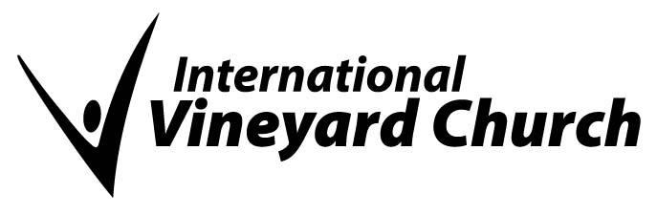
International Vineyard Church Statement of Faith
WE BELIEVE that there is one living and true GOD, eternally existing in three persons, The Father, the Son, and the Holy Spirit, equal in power and glory: that this triune God created all, upholds all, and governs all.
WE BELIEVE that the SCRIPTURES of the Old and New Testaments are the Word of God, fully inspired, without error in the original manuscripts, and the infallible rule of faith and practice.
WE BELIEVE in GOD THE FATHER, an infinite, personal Spirit, perfect in holiness, wisdom, power and love; that He concerns Himself mercifully in the affairs of humanity; that He hears and answers prayers; and that He saves from sin and death all who come to Him through Jesus Christ.
WE BELIEVE in JESUS CHRIST, God's only begotten Son, conceived by the Holy Spirit. We believe in His virgin birth, sinless life, miracles and teachings, His substitutionary atoning death, bodily resurrection, ascension into heaven, perpetual intercession for His people, and His personal and visible return to earth. We believe that in His first coming Jesus Christ inaugurated the fulfillment of the Kingdom of God.
WE BELIEVE in the HOLY SPIRIT, who came forth from the Father and Son to convict the world of sin, righteousness, and judgment, and to regenerate, sanctify and empower for ministry all who believe in Christ; we believe the Holy Spirit indwells every believer in Jesus Christ and that He is an abiding Helper, Teacher, and Guide. We believe in the present ministry of the Holy Spirit and the exercise of the Biblical gifts of the Spirit.
WE BELIEVE that ALL PEOPLE are sinners by nature and choice and are therefore under condemnation; that God regenerates, by the Holy Spirit, those who repent of their sins and confess Jesus Christ as Lord.
WE BELIEVE in the universal CHURCH, the living spiritual body, of which Christ is the Head and all regenerated persons are members.
WE BELIEVE that the Lord Jesus Christ committed two ORDINANCES to the Church: Baptism and The Lord's Supper. We believe water baptism is available to all Christian believers following a clear profession of Christian faith. We believe that the Lord's Supper is open to all believers.
WE BELIEVE in the personal, visible, APPEARING OF CHRIST to earth and the establishment of His Kingdom; the resurrection of the dead, the final judgment and the eternal blessing of those who receive Christ and become children of God and eternal conscious punishment of those who reject Him.
WE BELIEVE that the BIBLE in its entirety is the inspired word of God, and that its writings are eternal truths that are to be experienced and practiced by believers for all time.

